DreamSaver V 1.0

Software Requirements Specification Document

For

Netsmartz LLC,
3495 Winton Place,
Rochester NY - 14623

By

Sebiz InfoTech Pvt. Ltd., C-136, Industrial Area,
Phase –8, Mohali, India

Table of Content
Contents
1 Introduction 4
1.1 Application Overview, Scope & Objectives 4
1.2 Application Objectives 4
1.3 Purpose of the Document 4
Application Environment 5
1.4 Technology Environment 5
1.5 External Interfaces 6
1.6 Portability Requirements 6
2 Functional Description of DreamSaver Software 7
3 Screens 9
3.1 Login Screen :- 9
3.2 Main Screen :- 9
3.3 User Images Screen:- 11
3.4 User website Info Screen:- 12
3.5 User video Screen:- 13
3.6 User Public Folder Screen:- 14
3.7 User Private Folder Screen:- 15
4 Application Settings: 16
4.1 Setup Folder Location: 16
5 Browser Functionality: 16
5.1 Bookmark Creation: 17
5.2 DreamSaver Bar: 17
5.3 Synchronization of Files: 17
5.4 DreamSaver Storage Bin folder: 17
6 HELP: 18
6.1 Online Help: 18
6.2 Getting Started Guide: 18
6.3 My Account: 18
6.4 About: 18
7 Other Requirements: 18
7.1 Performance requirements: 18
7.2 Data Archival and Retrieval Requirements: 19
8 Issues & Concerns: 19
8.1 Assumptions and Dependencies: 19
8.2 Design and Implementation constraints: 19
8.2.1 Browser compatibility: 19
8.2.2 Design: 19
8.2.3 Middle Tier: 19
8.2.4 Data Tier: 19
8.3 Security System 20
9 References 20
10 Appendix 20

Introduction

Application Overview, Scope & Objectives
Dream Saver is a website and drag-n-drop software enabling the user to add such application to their internet browser (latest versions of Microsoft Internet Explorer, Google Chrome, Firefox and Safari). This application, once installed gives user the ability to drag and drop pictures, web site text, videos, and website URL’s, so they can save this information to the Dream Saver server (third party storage servers such as the cloud servers of Amazon or the Planet). The items that the user decides to add to their Dream Saver gallery is nameable and the user is able to create specific folders to save their items too. Once these pictures, web texts, websites, videos, and URL’s are saved to the server, the user has the ability to visit their profile and make backups of the information in Encrypted Box.
The Dream Saver application will be useful in creating PowerPoint presentations because the user can create specific project folders and then save research information to those folders. The user will have the ability to search the web for desired images or articles, and then save the information to the server so they can access the information on any computer and anywhere with internet access. This information will help the user if they are using a public computer by giving them the ability to not store the information on a flash drive. Flash drives can only store a certain amount of information, and when the user is saving large amounts of text, video, and pictures it makes it easier for the user to use an application such as Dream Saver.
The Dream Saver application will be viewable by latest versions of all major internet browsers such as Google Chrome, Internet Explorer 9, Firefox and Safari.

Application Objectives
- To enable the user to save, manage and search the stored documents at single location.
- To achieve the goal of security, speed, scalability, flexibility and modularity.
- To create shared folder on all systems where DreamSaver application is installed.
- Facility to sync your files online and across your computers automatically based on profile settings.
- Files are synchronized in the background with no intervention from the user.
- Manage all documents and media in one place (In your DreamSaver Bin folder).

Purpose of the Document
The purpose of this document is to lay out in detail the functional and other requirements of the application. This document contains the necessary information to meet the requirements set forth for the completion of this application, and to provide a general overview of the product, its target audience and general features of the product.

Application Environment

Technology Environment

Following are the minimum hardware and software requirements for building this application
Hardware Environment (Deployment Server)
Processor | Intel Pentium Processor 4 or equivalent
RAM | 512 MB (1 GB or above recommended)
HDD | 10 GB or above recommended.
Internet Connection | DSL
Software Environment (Deployment Server)
Operating System | MS Windows XP or later
IDE | MS Visual Studio 2010, Internet Information Services (IIS 7.0)
Web Server | Microsoft IIS 7.0
Browser | IE 7.0 and 8.0,  Mozilla Firefox 3.0 or above.
Software Environment (End User)
Operating System | Windows 2000, XP or higher
Browser | IE 7.0 and 8.0, Mozilla Firefox 3.0
Development Environment
Operating System | Windows XP
Technologies | ASP.Net 4.0, SQL Server 2008, Ajax, LINQ
Programming Language  Database | C#.Net  SQL Server 2008

External Interfaces

Hardware Interface
- Intel® Pentium® 4 (equivalent) or higher recommended
- 512 MB (1GB RAM or above recommended)
- 1 GB of free hard disk space.
- SVGA monitor with 256 colors and 1024 x 800 resolutions.

Software Interface
- Intel® Pentium® 4 (equivalent) or higher recommended
- 512 MB (1GB RAM or above recommended)
- 1 GB of free hard disk space.

User Interface
- Windows programming standards and conventions are to be followed. Along with a custom GUI i.e. use of non-conventional colors.

Third Party
Note: All the paid third party controls will be purchased by client.

Portability Requirements
N/A

Functional Description of DreamSaver Software

- After successful installation, when the application runs for the first time, it will create a folder structure in the user’s system. i.e Public and Private Folders and a Drop bar will be created on all the browsers installed on the client’s system.
- When the user Drag n Drop items on the Drop Bar in the Browser, the data will be saved in the local DreamSaver Storage Bin Folder. From this local repository of data, the user can selectively synchronize the data with the DreamSaver Server.
- The Drop bar will be attached to browsers and not to the desktop itself. If something is dragged to the bar, the data will be stored onto the local folder structure created by desktop app i.e. “DreamSaver Storage Bin”.

- The user can drag and drop pictures, web site text, videos, and website URL’s on the Drop bar only through the browser window. The drag and drop of items on the Drop bar directly from the desktop is not allowed.
- The items that the user decides to add to their Dream Saver gallery are nameable. The user can also create specific folders [Category] to store specific kind of files such as Images, text files, videos, website links etc.
- The Dreamsaver files will be primarily saved on the user’s local file system, except for the public folder whose content will automatically get synced with the DreamSaver Server whenever new file are added to it.
- The user has the ability to sync any file that they have in their local system folders with the DreamSaver server. Once the information is synced, it will be available for sharing on the Dreamsaver server. The files in the public folder will be automatically get synced and are available for sharing on the DreamSaver Server, whereas the files in the private folder will only be synced
explicitly by the user i.e All the files in the folders except public folder will not get automatically synchronized.
- The User will have option to selectively upload\sync the newly added\changed files.
- The added desktop feature will help reduce the amount of server space filled because users have to specify if they want to synch other folders as well.
The other folders except the public folders does not automatically synch with the server.
- The other folders except the public folder can be synched with the server manually but cannot be viewed by other users of the website. The public folder will be searchable by the other users of the website. For ex. “if a user is searching for a “ford mustang” they should be able to see what other users have in their public folder from the user’s saved description of the file. The other folders that appear on the server will not be searchable by other users. These folders will be only viewed by the user.
- Once info is synced on the Dreamsaver server that can be shared to other users though DS web site. The user has a public folder that other users can see on the server. The public folder will act as a shared folder that users can also search through dream saver website and can access the other people’s files.

- Once these pictures, web texts, websites, videos, and URL’s are saved to the server, the user has the ability to visit their profile on the DreamSaver website and make backup of their stored information in Encrypted Box Application. [An option to backup data on Encrypted Box will be provided in the user profile settings in DreamSaver application. Encrypted Box is a separate application requiring separate login credentials than DreamSaver.]

Screens

Login Screen :-

The Login Screen is the first screen that comes after installation
The login screen window contains two fields to enter User name and password. Registered user can login to the system with the User name and password that s/he had chosen while registering on website.
Username is treated as login ID for DreamSaver application which is unique for every user.

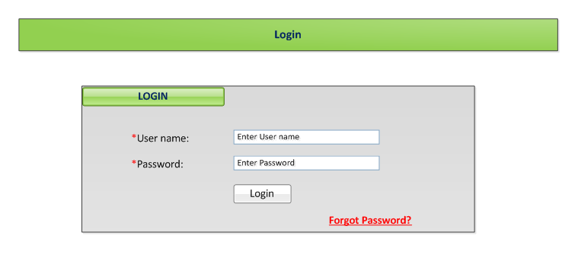

If one forgets the username or password then s/he has to click on the forgot username/password link and this would be retrieved from the DS website.

Main Screen :-
After verifying the user credentials, the Main screen will open.
The Main screen contains menus items for Settings, Help and Exit.
The DreamSaver storage bin gives user a separate storage space for storing data. The user can store their photos, videos, text and website information to a folder that is available offline to the user.

The screen shots below shows how the User’s information will be displayed categorically in the DreamSaver Bin Folder.

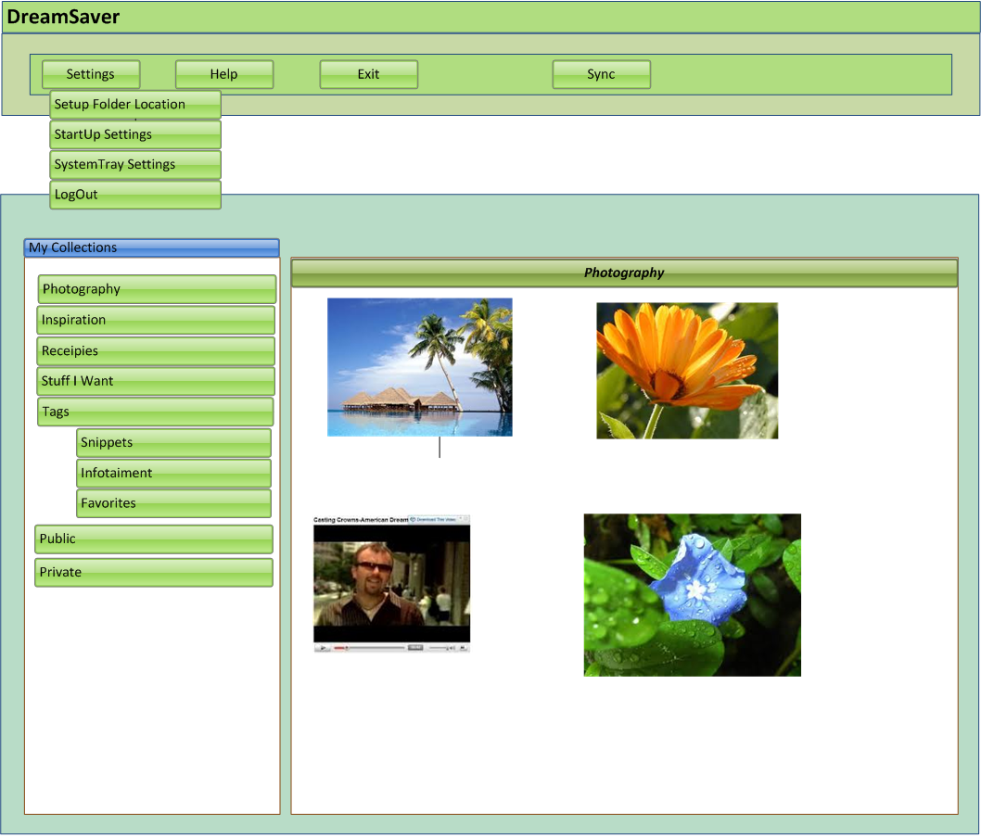

User Images Screen:-

The screen shot below shows how the user’s images will be stored in the Dream Saver storage bin in a separate folder entitled ‘Images’
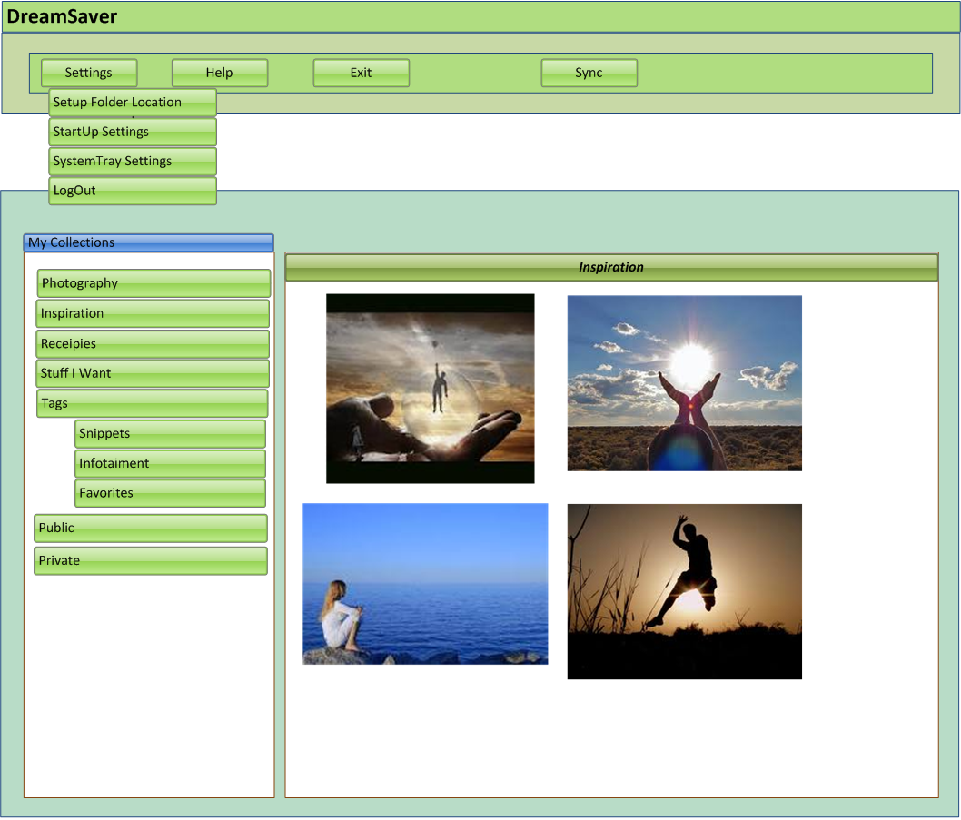

User website Info Screen:-

The screen shot below shows how the user’s website extractions will be stored in the Dream Saver storage bin in a folder entitled ‘Websites’.

User’s full website extractions will appear in a separate sub folder named ‘websites’ within Dream Saver with the entire user’s website info.

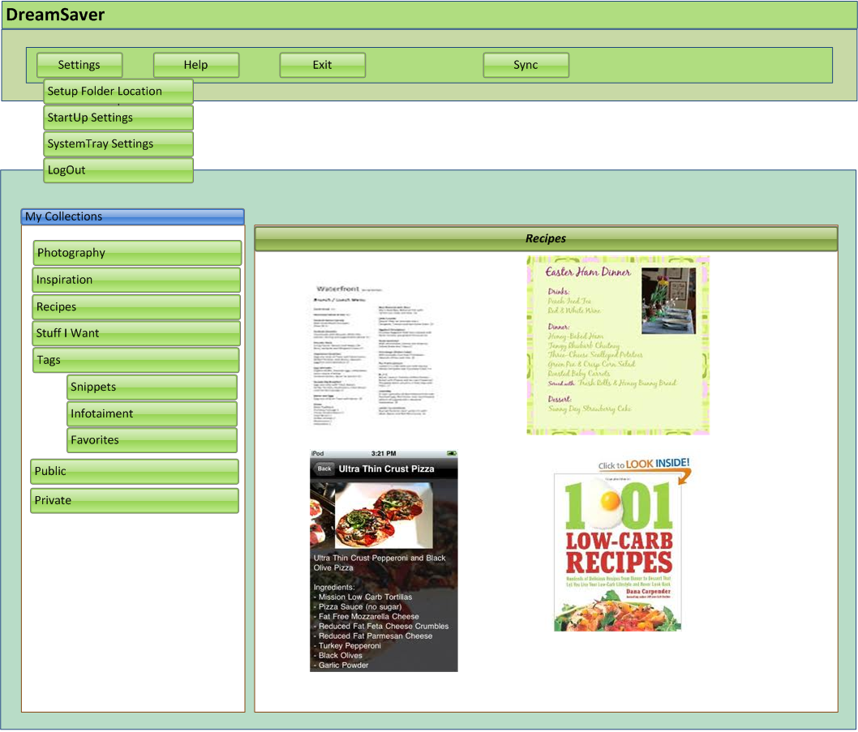

User video Screen:-

The screen shot below shows how the user’s videos info will be stored in the Dream Saver storage bin in a separate folder entitled ‘Videos’.
The user’s videos are stored in a sub folder entitled videos within the Dream Saver main folder.

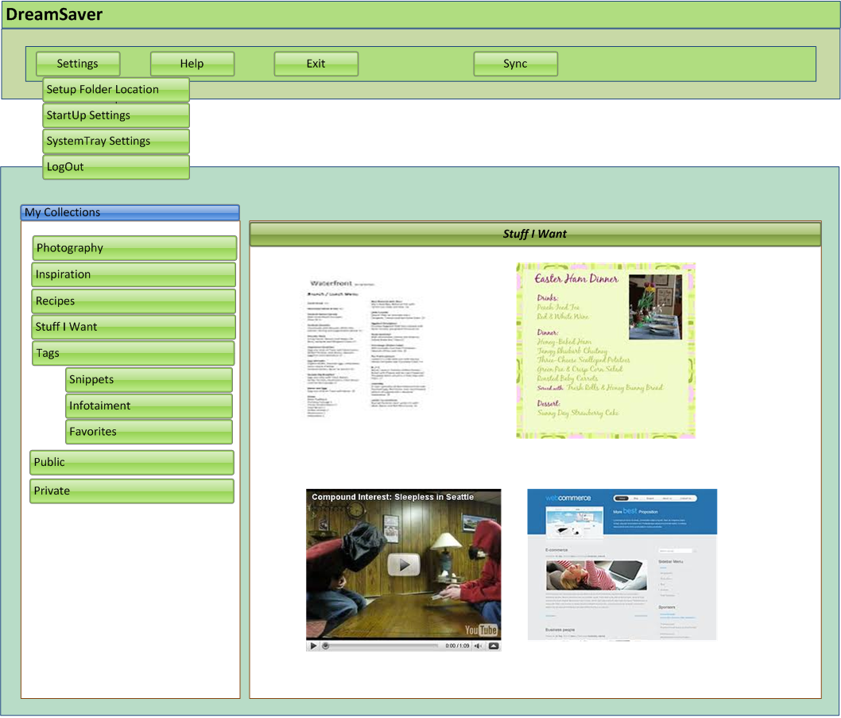

User Public Folder Screen:-

Anything that the user has in their public folder will appear in the server so that other users can view it.
Users can have subfolders in their public folder that will separate different types of files into separate folders.
Below is the screen shot of user’s public folder showing an assortment of different files such as text, images, videos and websites.

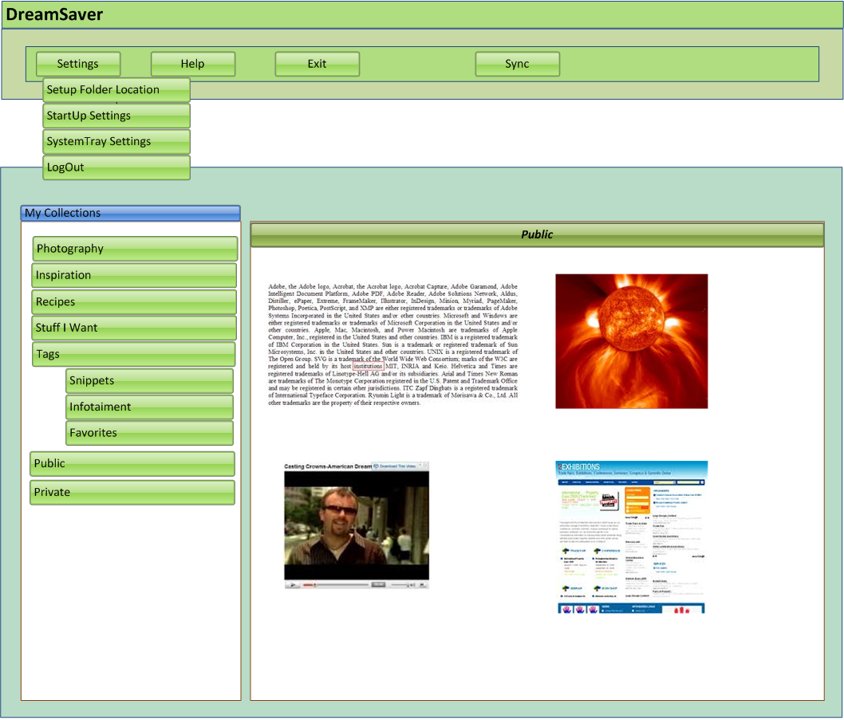

User Private Folder Screen:-

The screen shot below shows the user’s Private folder. The user’s private folder will have information that the user wants to keep private from other users. The private folder contains text, images, videos and website info that the user wants to keep private in their Dream Saver folder.

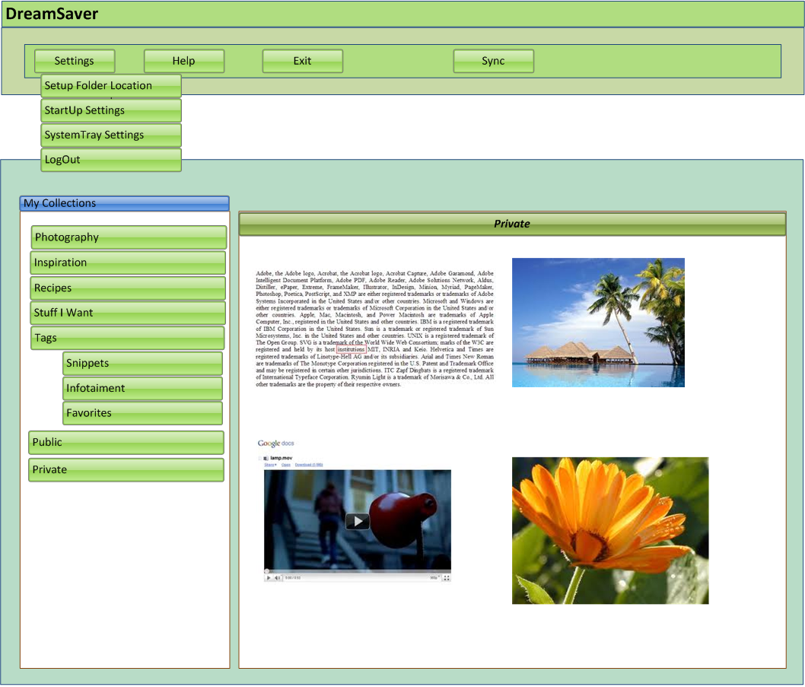

The files in the Dream Saver storage bin will be synchronized with the Dream Saver website and server. Once the files are synchronized they will appear in the user’s Dream Saver account as shown in the screen shots above.

Application Settings:

This section will contain options for various application settings like:

Setup Folder Location:
By using this option, the user can set the location for the Dream Saver Storage Bin folder. The files in the Public folder will be accessible to all of the Dream Saver users on the website whereas files in private folder will be hidden for all of the users on the website.

4.2 Startup Settings:

With this option, the user can control whether or not to start the DreamSaver application at system startup.

4.3 System Tray Settings:

A graphical image icon will be displayed in the system tray when the application starts. Double clicking on this icon will start the DreamSaver application and by right clicking on this system tray icon, it will display all the menu items as mentioned in item 3.2.1 in the context menu. i.e.
- Show Public Folder
- Show Private Folder
- My Account
- Exit

Browser Functionality:

This section will contain various options for browser settings. When the user install DreamSaver product, all the Browser related features will be installed automatically like:

Bookmark Creation:

When the DreamSaver application first starts, it will check for all compatible browsers installed on the user’s system, and a bookmark for the application will be created in each of the browser’s favorites list. When user will click on bookmark, A Dream Saver bar will appear in the browser window (with private and public section) on which the user can drag and drop his/her selected items.

5.2 DreamSaver Bar:

A DreamSaver Bar will be installed in the browser window displaying two sections i.e. Public and Private, in which the user can drag and drop items like text files, formatted text, images, videos etc. The items in the public folder will be accessible to all the users of the application through website, whereas the private folder’s content will be accessible only to the user who uploaded them.



5.3 Synchronization of Files:
When the items are dropped on to the Drop Bar, the content will be stored in the local system DreamSaver Storage Bin.
Now, from this DreamSaver storage Bin, the data can be synchronized selectively with the DreamSaver Server. This synchronized data will then be available to the users through DreamSaver website interface.

5.4 DreamSaver Storage Bin folder:

The DreamSaver Storage Bin folder will contain two folders i.e public and private. It will be on the user’s local file system, and any content dropped on the DreamSaver Bar will be first stored in this storage bin. Application tracks all new files in local DB and when connected with Internet connection, it will automatically synchronize with the DreamSaver Server.

HELP:

Online Help:

The Online Help offers all of the help documents that are built into DreamSaver. Online help is topic-oriented, procedural or reference information for user assistance.

Getting Started Guide:

This guide is intended as a reference for those working with DreamSaver for the first time, but is also intended to serve as a cookbook with self-contained references and solutions for common use cases. For users more familiar with DreamSaver, this guide will provide a quick solution for the need at hand.

My Account:

This option is available for the user to access his/her DreamSaver account, from where he/she can edit/update any of their account settings via website interface.

About:

This contains the information about the DreamSaver version you are using and any copy right information involved.

Other Requirements:

Performance requirements:

Following are some of the performance requirements that shall be maintained by the product.
- The publishing of the output should be quick as per industry standards.
- Should be easily downloadable and installable.
- System shall be compliant with windows operating system XP and Vista.

7.2 Data Archival and Retrieval Requirements:
N/A

Issues & Concerns:

Assumptions and Dependencies:

The System is based on the following assumptions/dependencies: -
User should be connected to Internet while login to software.

Design and Implementation constraints:

Browser compatibility:
The website would be tested for compatibility with the following web browsers:
- IE 7.0 and above.
- Mozilla Firefox 3.0 and above
- Chrome

Design:
- CSS format for global control.
- Module based.

Middle Tier:
- Extensive Error reporting through email or log file.
- Module based.
- C#, the programming Language used to develop application.
- Data layer which calls stored procedures.

Data Tier:
- We will create all Database schemas in SQL Server 2008, i.e. stored procedures and tables etc.
- The upload web service can be created for it.
- The DB structure in the new system will be changed according to the new requirements and the data migration through the script will not be possible.

Security System
The Application require username password to installation and use encryption method to upload data.
OTHER ISSUES:
- Security Certificates required
- Validation methods will be applied to check for any error prone or malicious inputs from the user.
- Executable Code and or scripts will be disallowed.
- Multiple login attempts (over three tries) will be disallowed.

References

http://www.gimmebar.com

Appendix

N/A

